ST10108446 Sibusiso Dlamini

APDS API Testing document

POE Final

Frontend and Backend

# Coverpage

Coverpage 1

MongoDB Database Setup 3

Key and Certificate Generations 4

Get from Database 4

Creating new posts in DATABASE 5

DELETE from Database 7

Users 8

Frontend 10

API: Get all posts 11

API: Register a new users 11

API: Logon user A 12

API: Create a new post User A 12

API logon User B 13

API: Create a new post User B 13

User B delete user A’s post 14

User A delete user B’s post 15

Security packages 16

Implementing express-brute, helmet, Morgan 17

Custom Error Messages 17

Security input field validation, password obscuring and sanitations 18

Service Auth 18

# MongoDB Database Setup

This section will be showing illustrations of the created database and tables

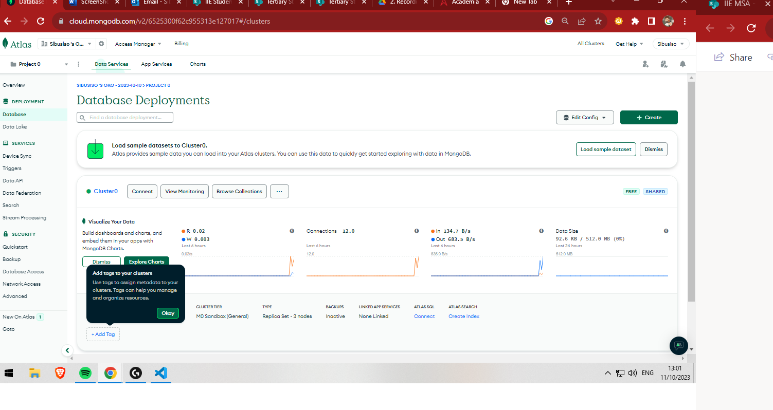

Figure1 : Mongo DB Setup

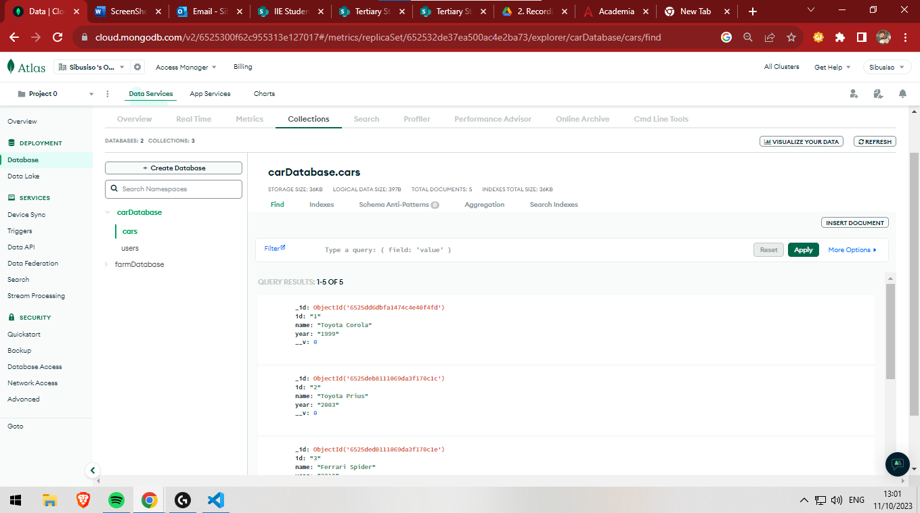

Figure 2: Database created

# Key and Certificate Generations

This section will be showing illustrations of how the private key and certificate was created

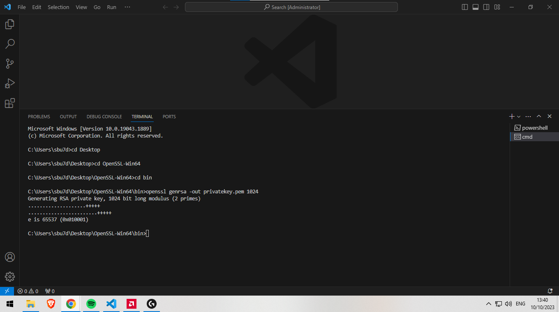

Figure 3: Private Key Generations

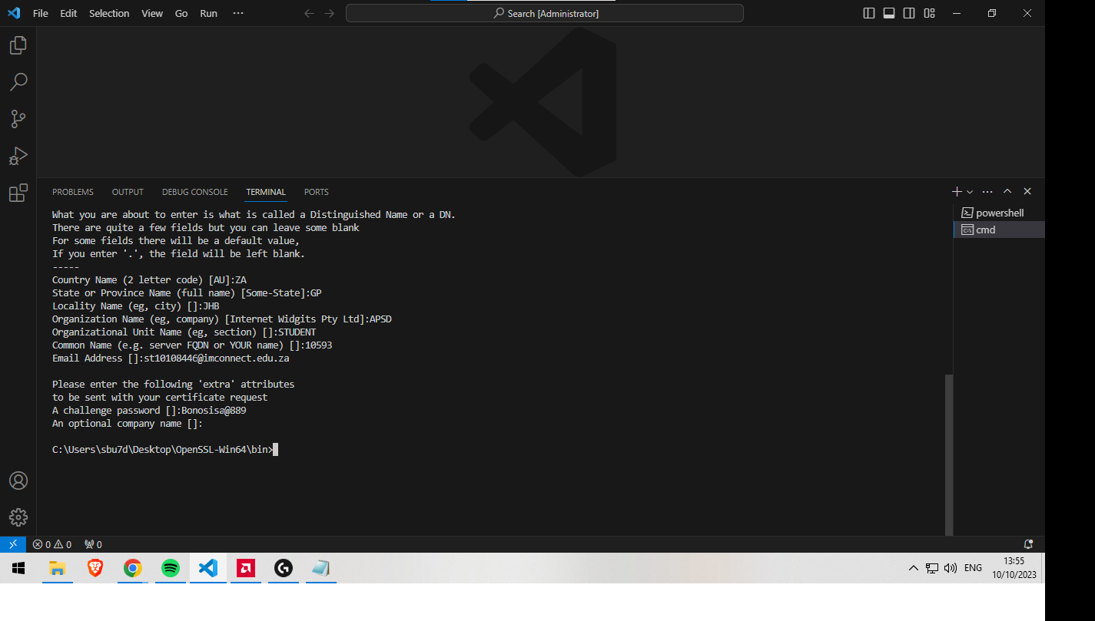

Figure 4: Certificate sign in request



Figure 5: Signing Certificate using private key

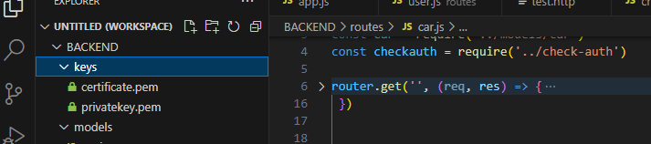

Figure 6: Key and Certificate in keys folder

# Get from Database

This section will be showing illustrations of the get method (which gets list of cars in the database)

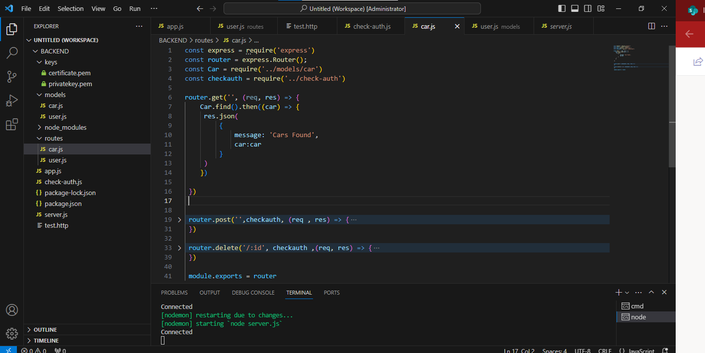

Figure 7: Code for getting Cars in database

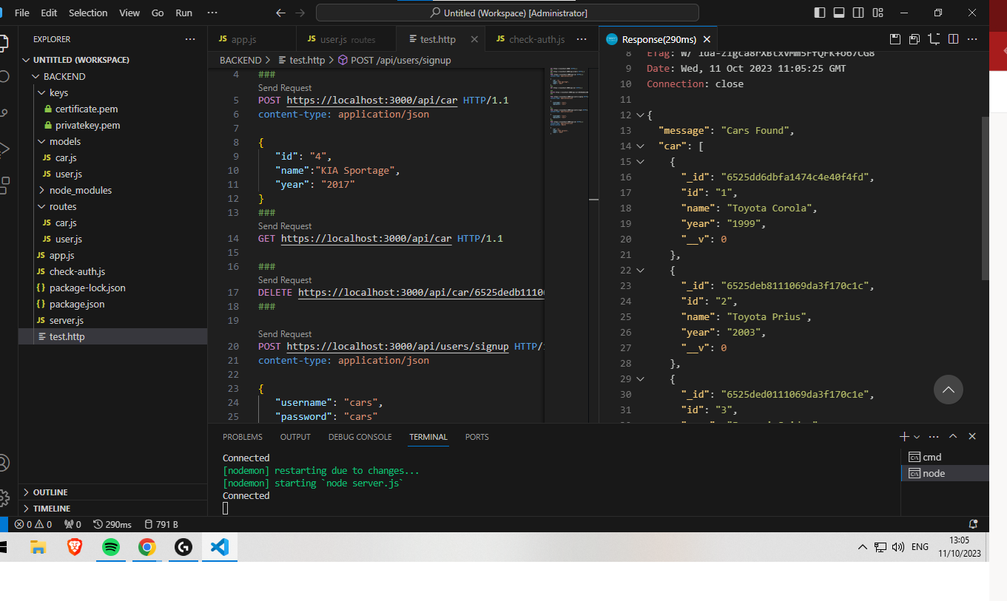

Figure 8: Showing test code for getting cars from database

# Creating new posts in DATABASE

This section will be showing illustrations of the post method (which will post new cars into the database)

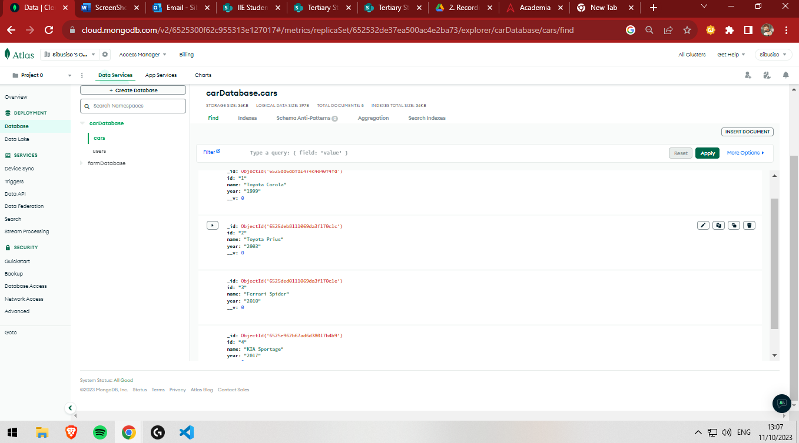

Figure 9: Database Pre-post

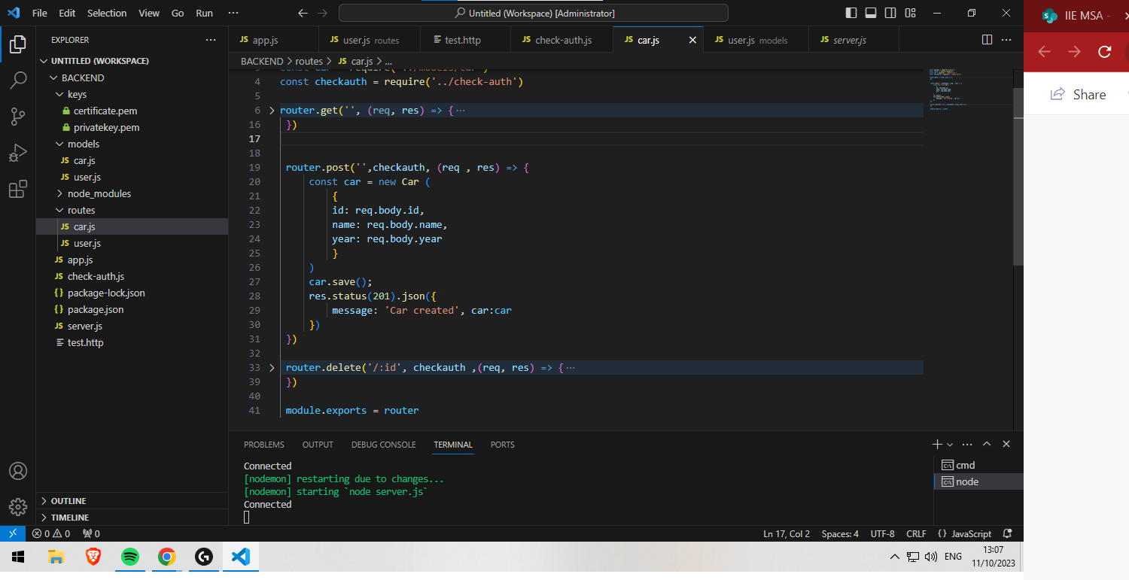

Figure 10: Route to Code for posting

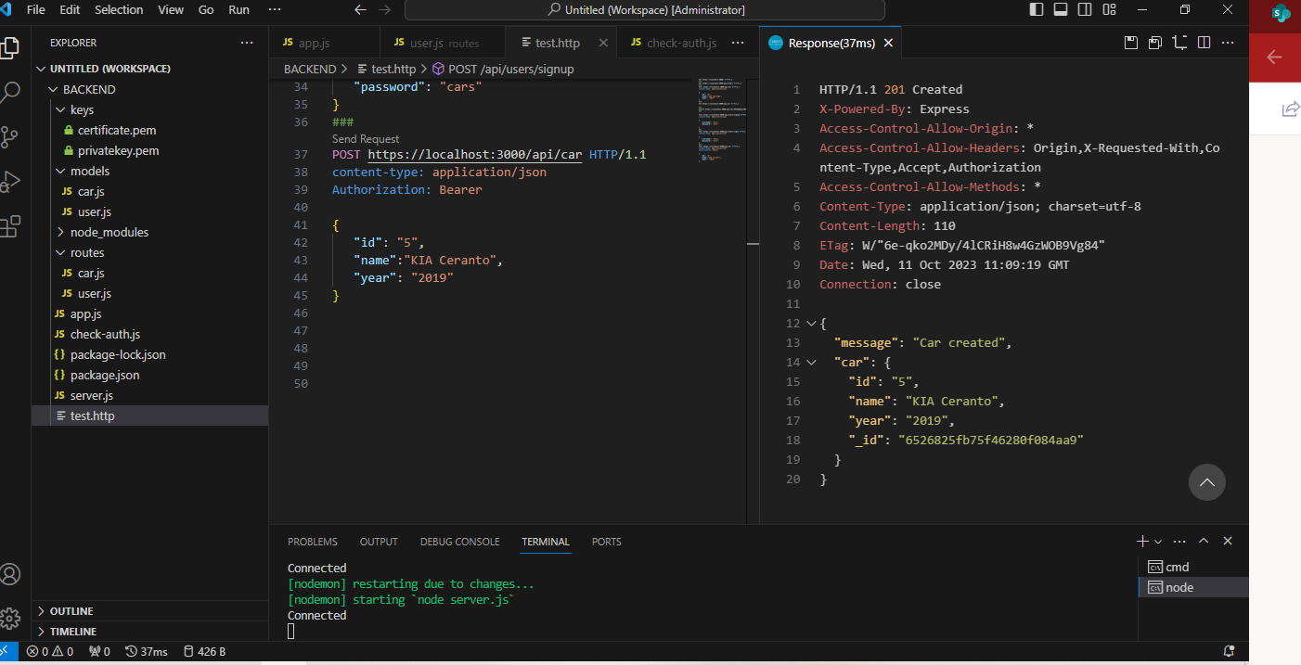

Figure 11: Posting to Database

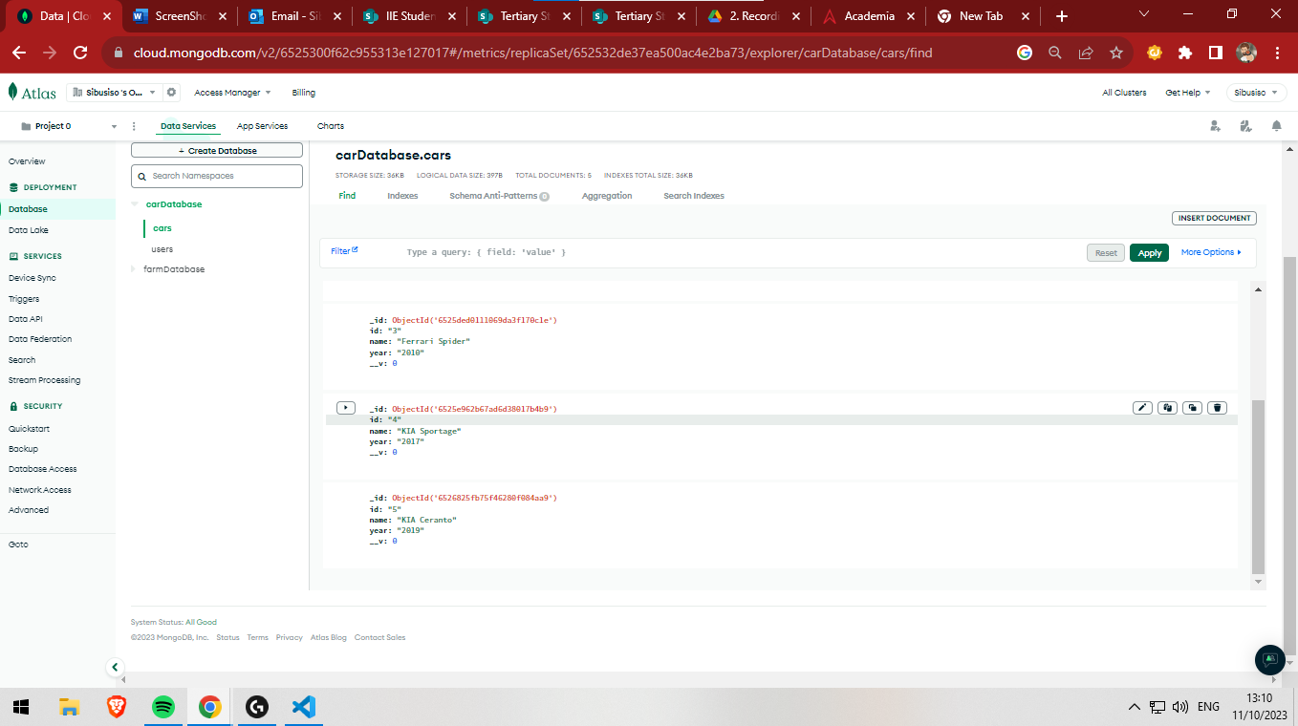

Figure 12: Database after post (before delete function)

# DELETE from Database

This section will be showing illustrations of the delete function (this allows users to delete cars from database)

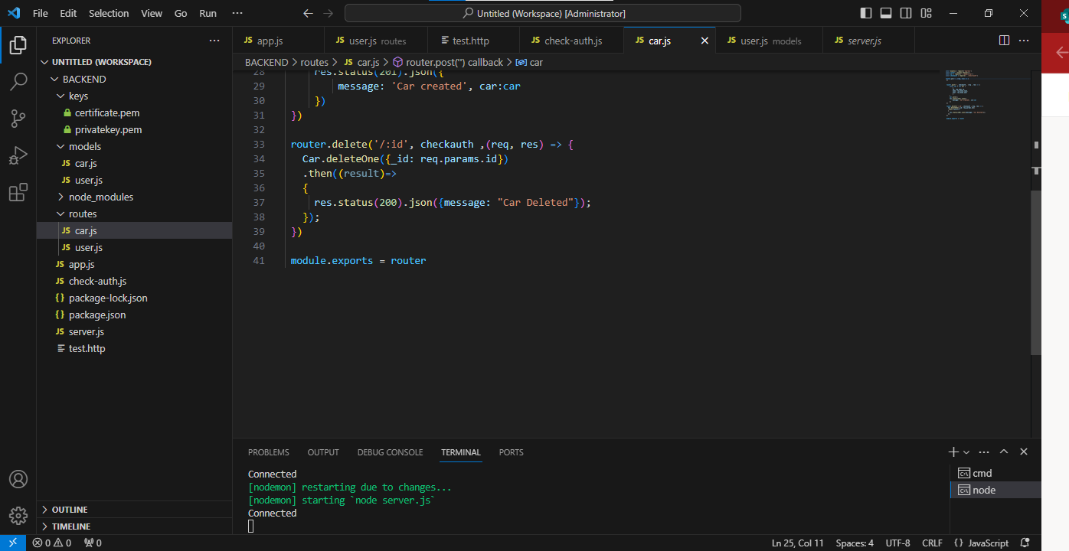

Figure 13: Route to Delete code function

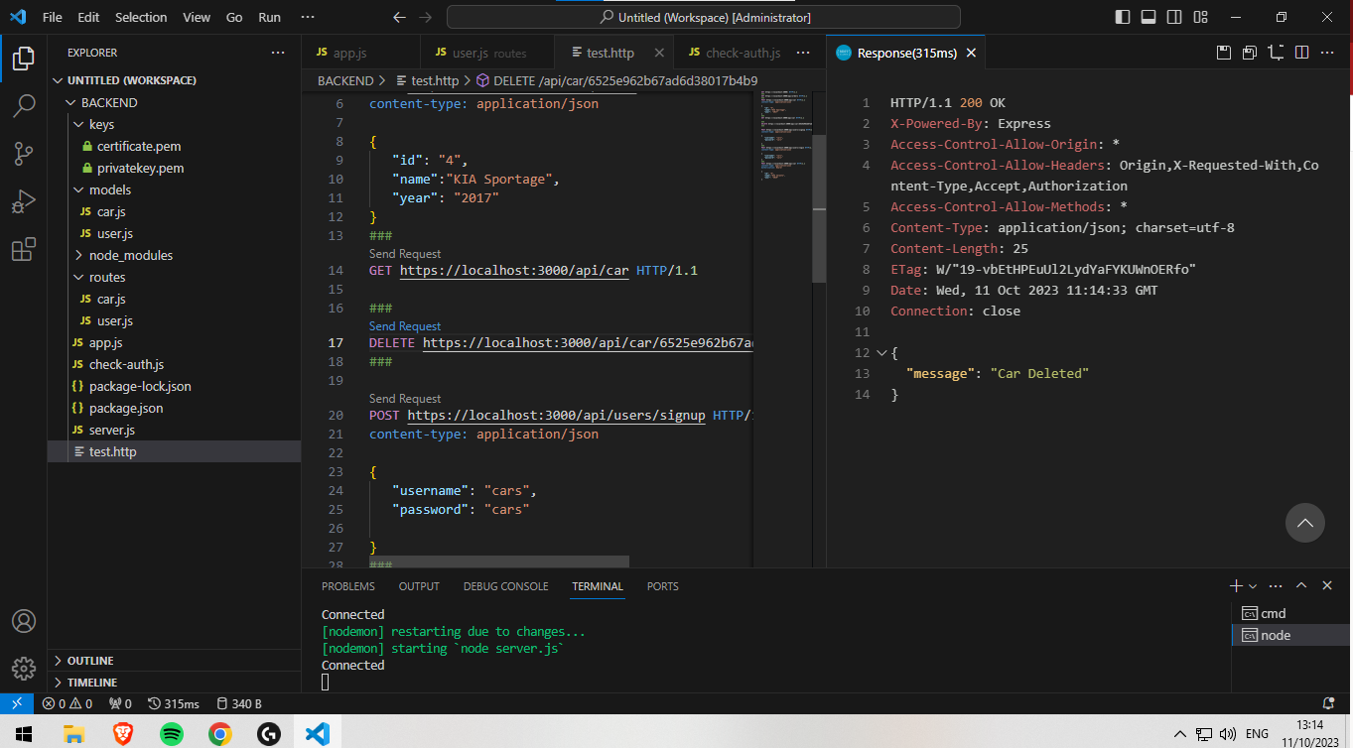

Figure 14: Running delete code for item ‘6525e962b67ad6d38017b4b9’ Kia Sportage, ID 4

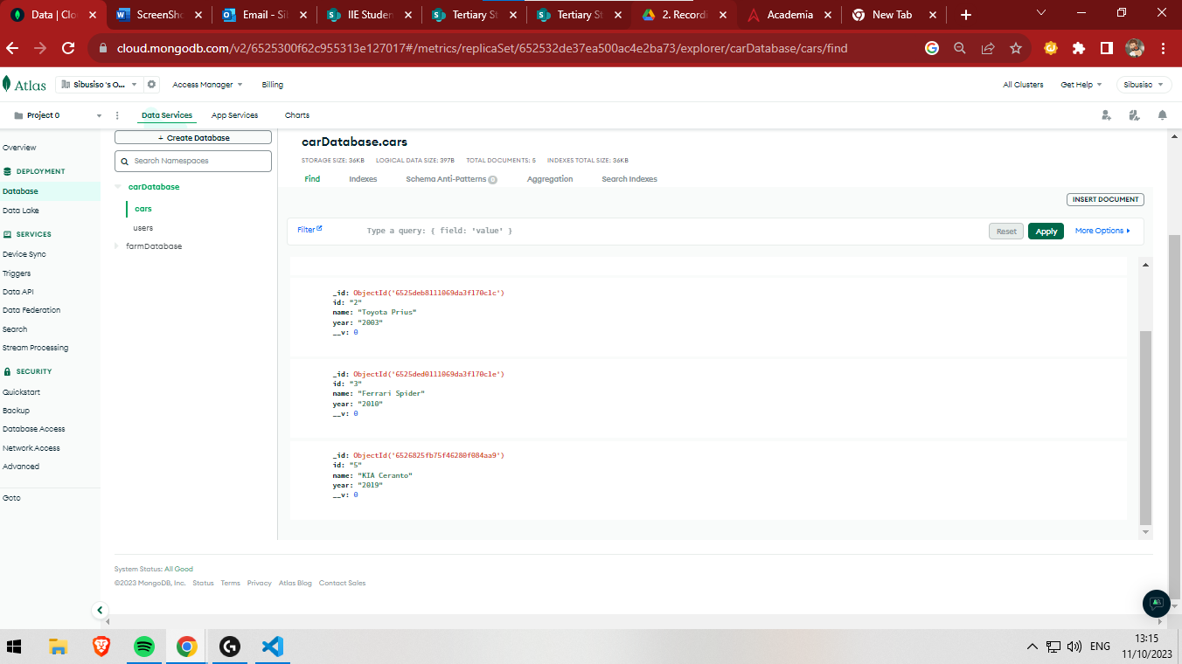

Figure 15: Database After Delete code

# Users

This section will be showing illustrations of how users will signup (added to database) and login

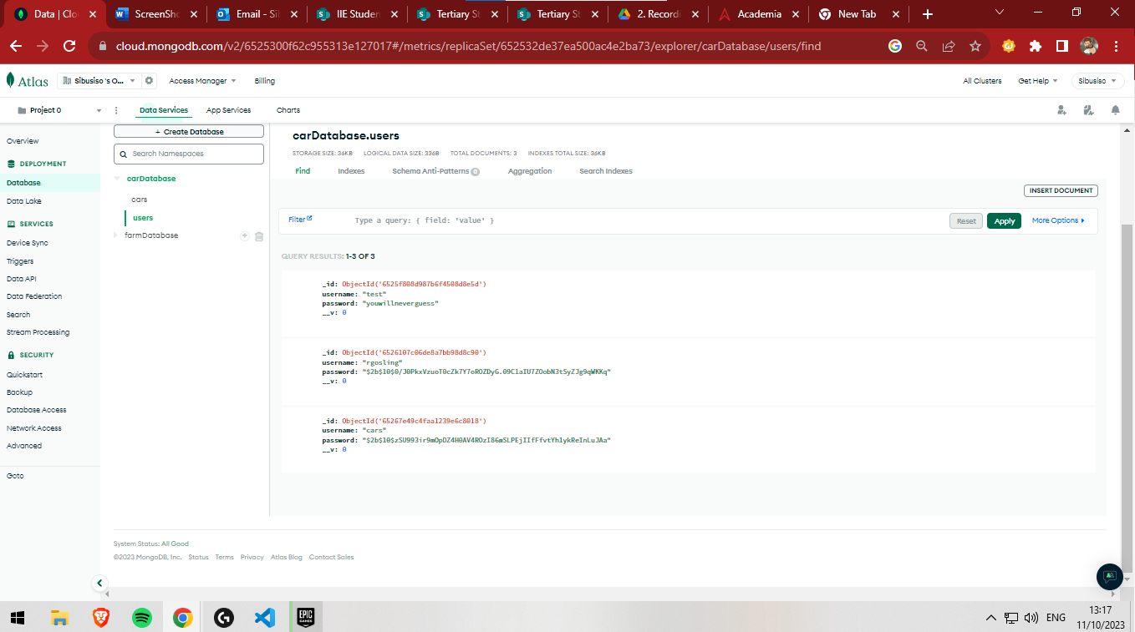

Figure 16: Users table in Database

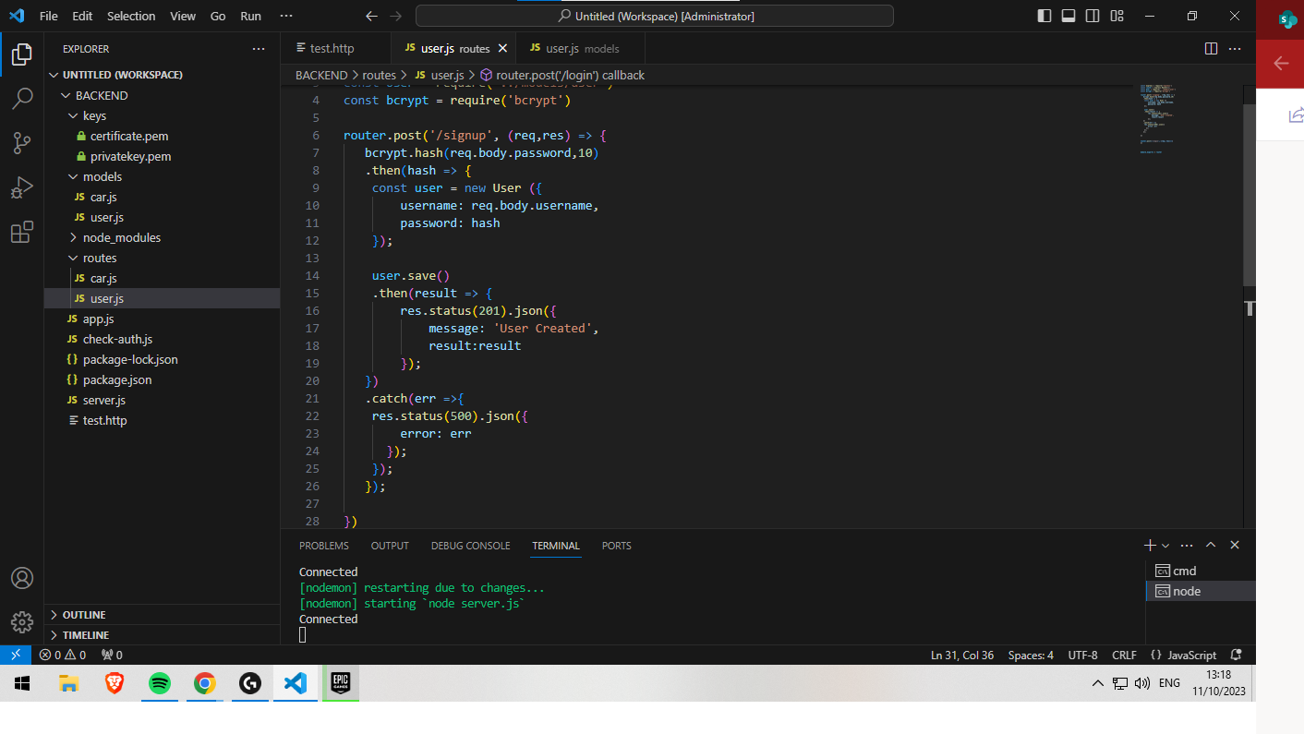

Figure 17: Route to code to sign up a new user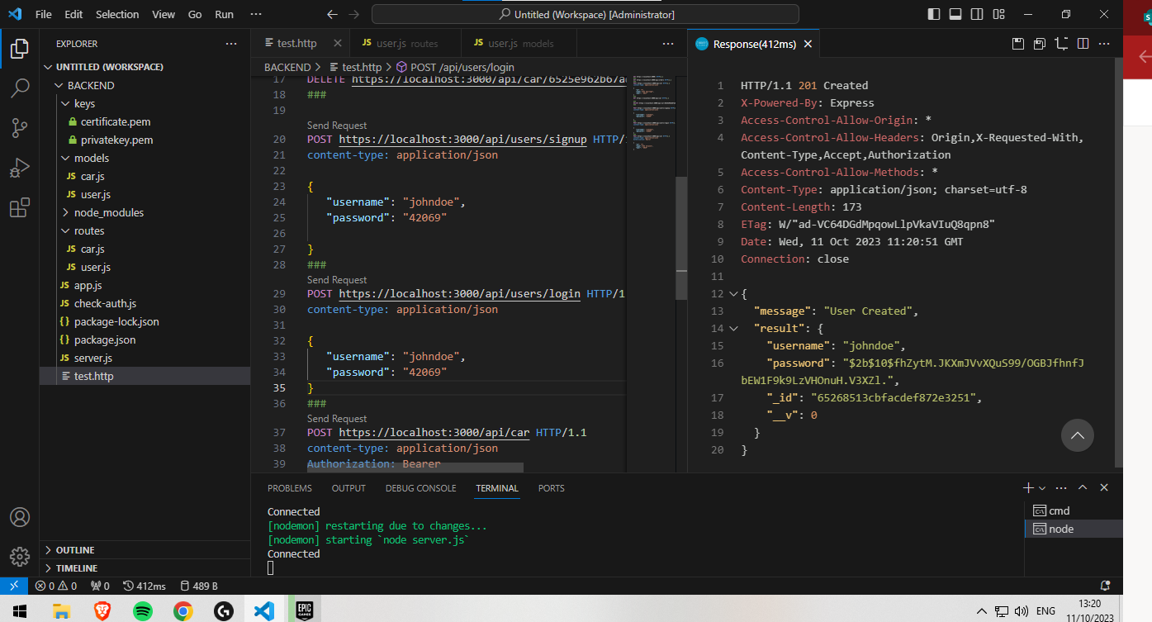

Figure 18: Code signing up a new user ‘johndoe’

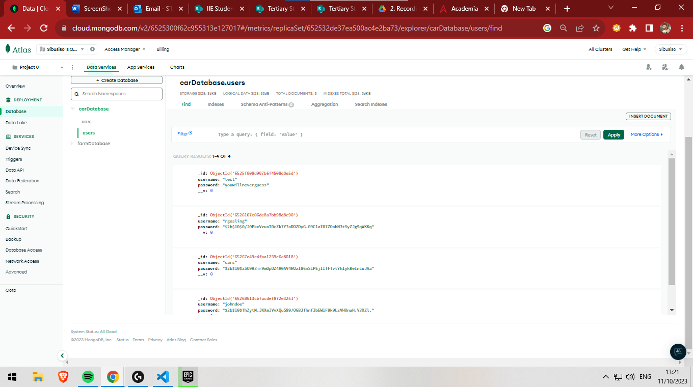

Figure 19: Database after new user is added

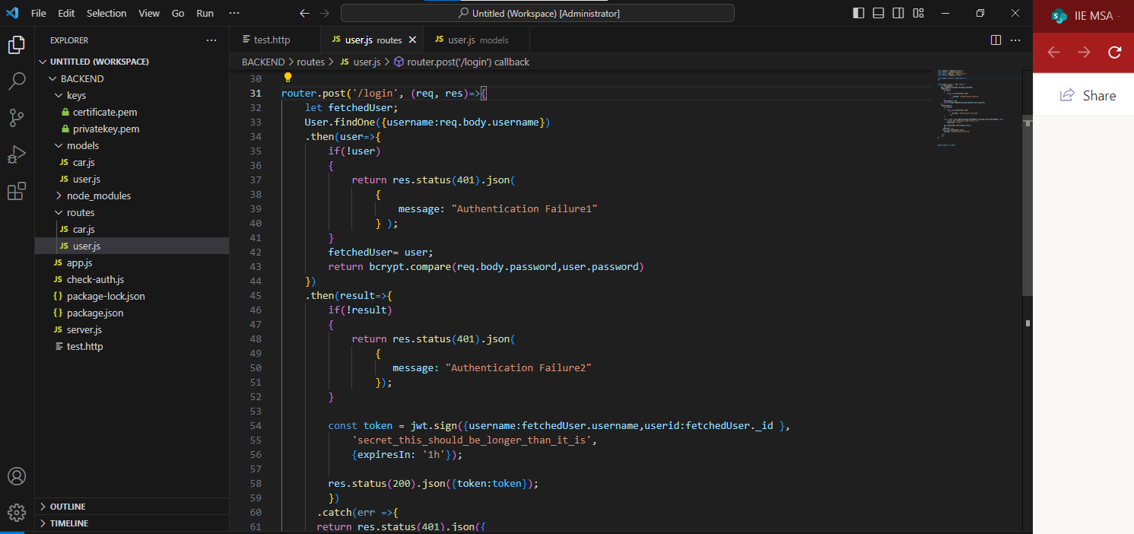

Figure 20: Code for login into application

# Frontend

## API: Get all posts

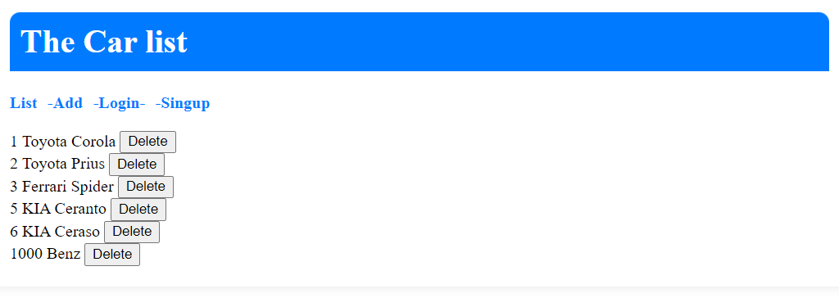

Figure 21: Shows list of cars from databaste

## API: Register a new users

Invalid fields

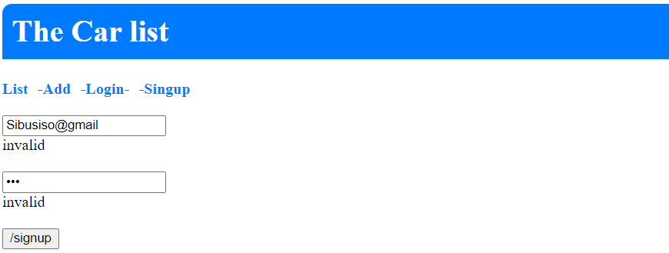

Figure 22: Shows error checking for invalid inputs

Valid Fields

User A

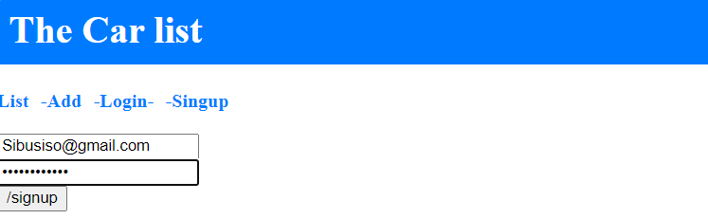

Figure 23: Shows the creation of new user A

User B

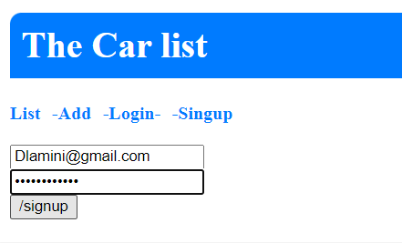

Figure 24: Shows the creation of new user B

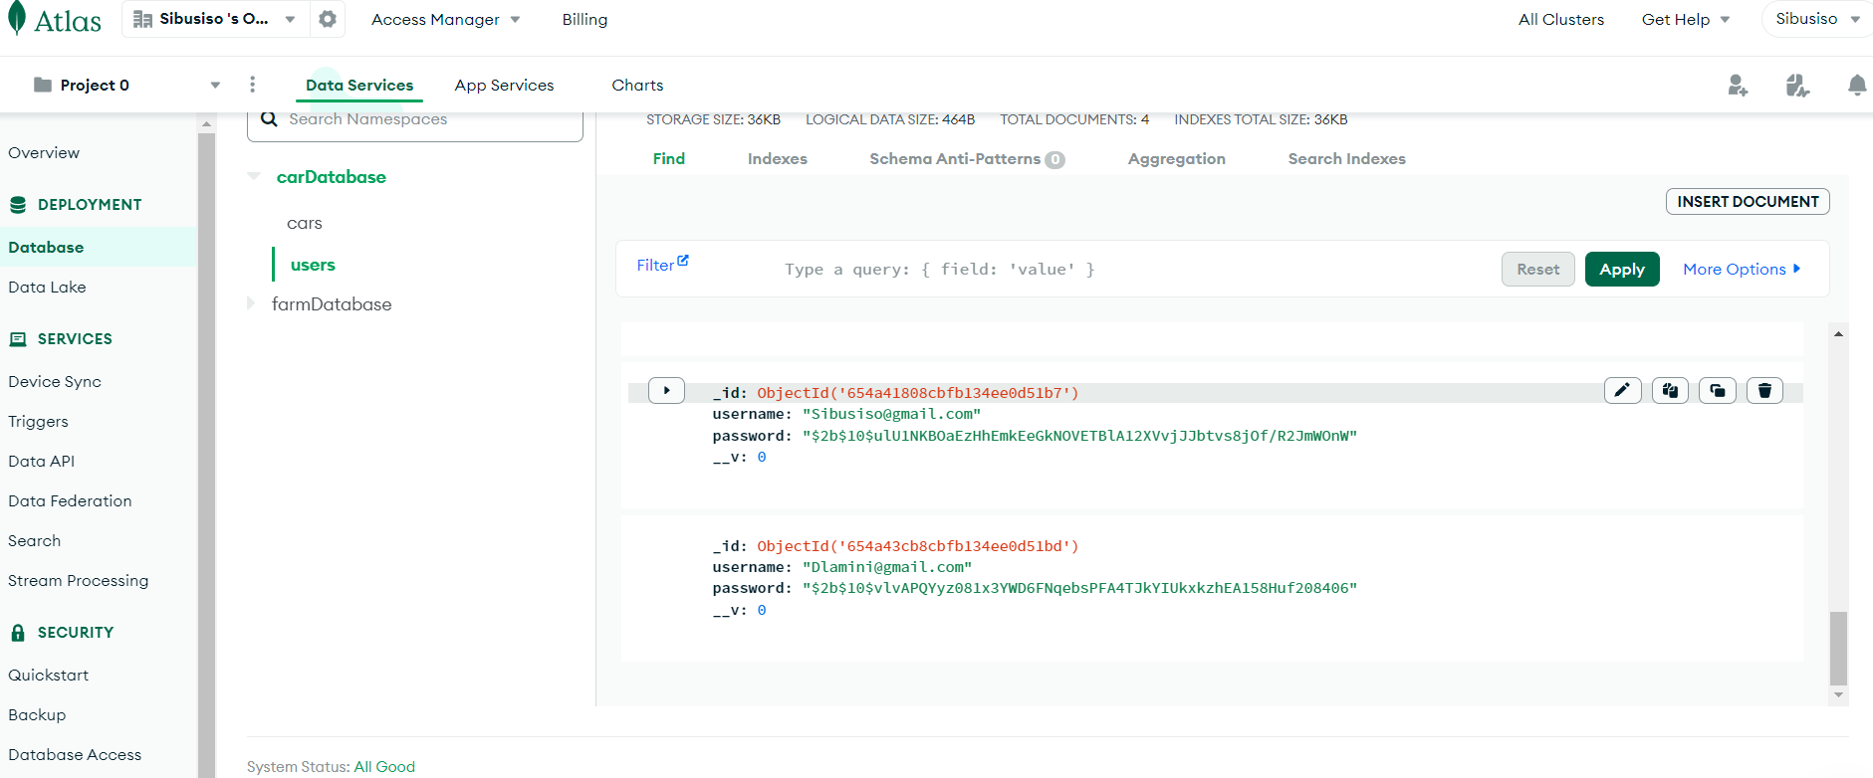

Figure 25: shows the created users in MongoDB

## API: Logon user A

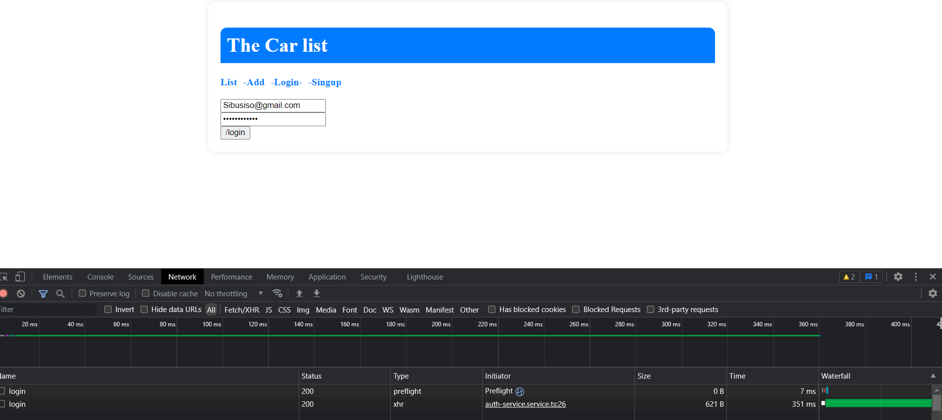

Figure 26: Shows user A logging in

No Error persist so user has been logged on

## API: Create a new post User A

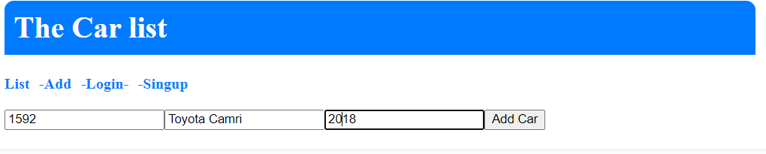

Figure 27: shows user creating a new post

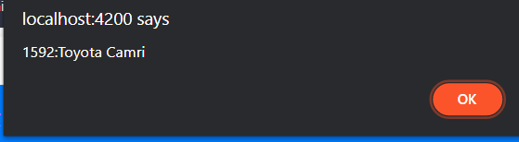

Figure 28: Confirmation of pose

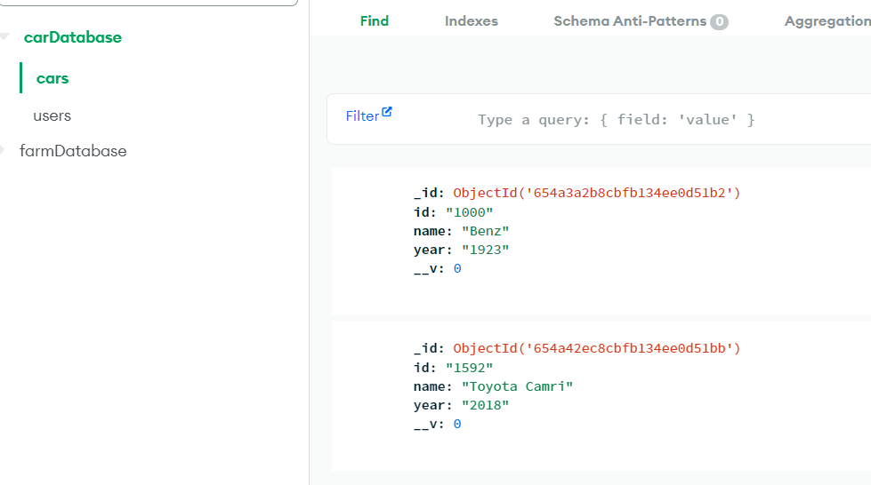

Figure 29: Shows the created post in MongoDB

## API logon User B

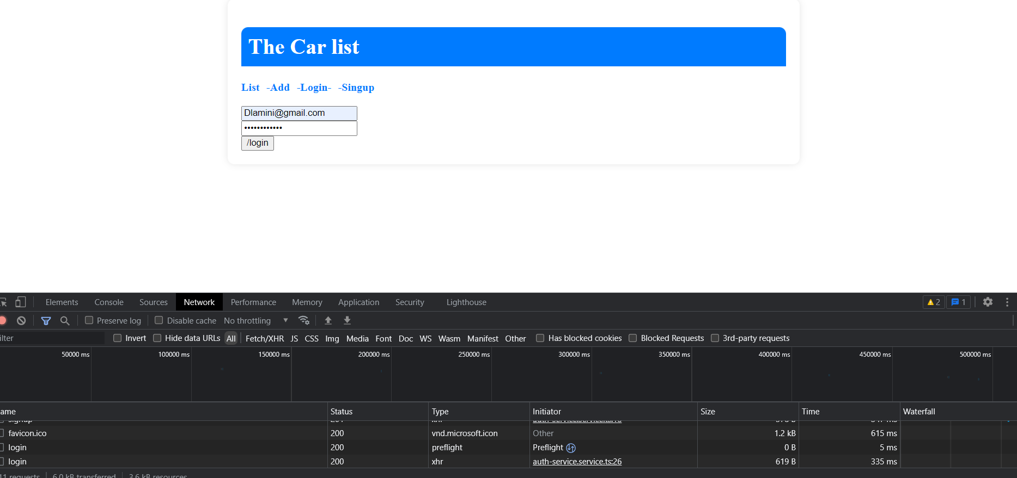

Figure 30: Shows user B logging in

No Error persist so user has been logged on

## API: Create a new post User B

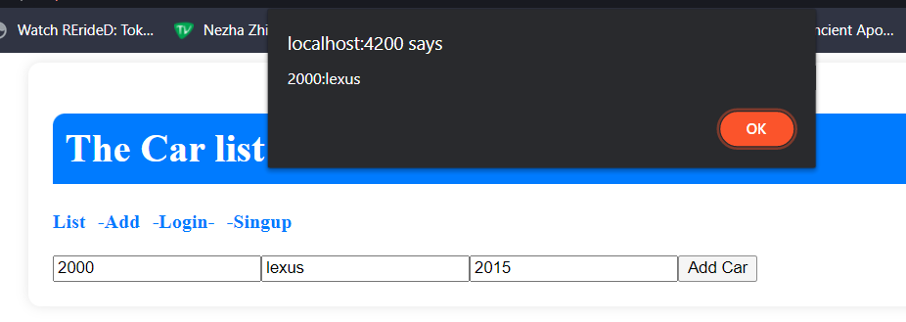

Figure 31: Shows user B creating a new post

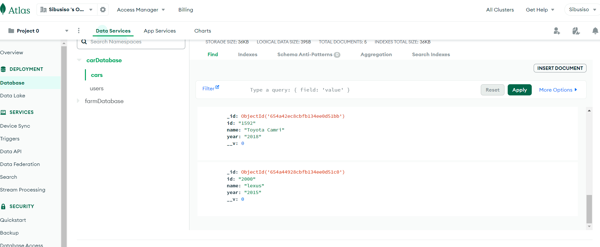

Figure 32: Shows user B’s post in MongoDB

## User B delete user A’s post

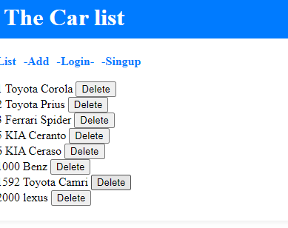

Figure 33:Shows the car list before deletion has taken place

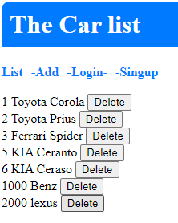Figure 34: Shows Toyata Camri post has been Deleted

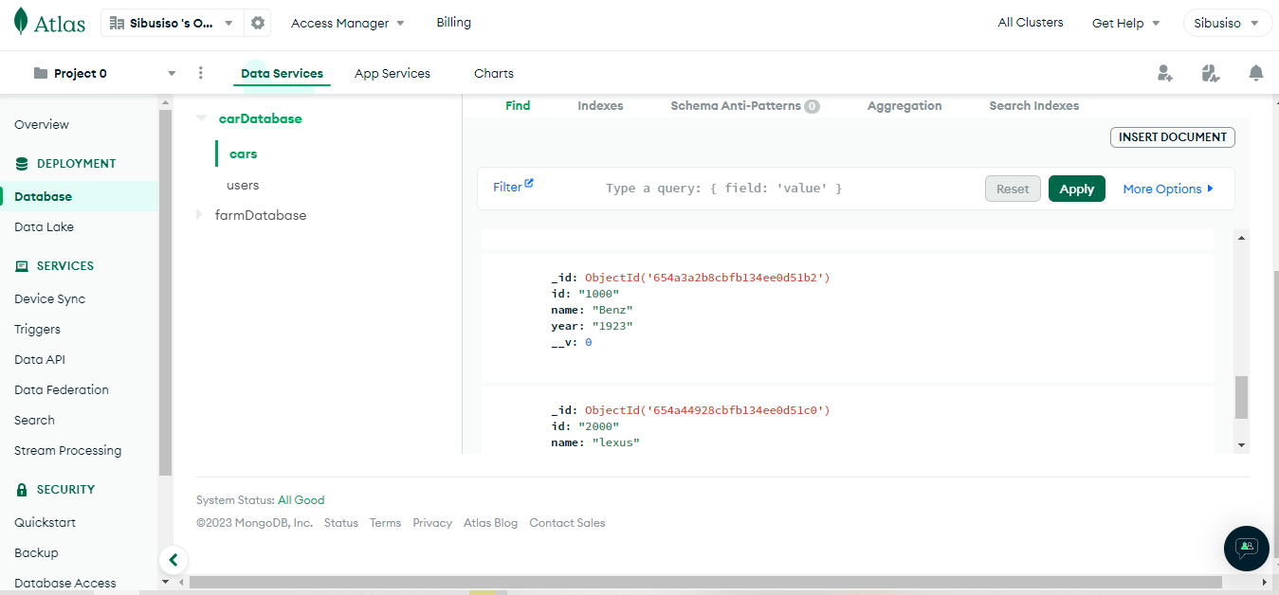

Figure 35: Shows Toyata Camri post has been Deleted from MongoDB

## User A delete user B’s post

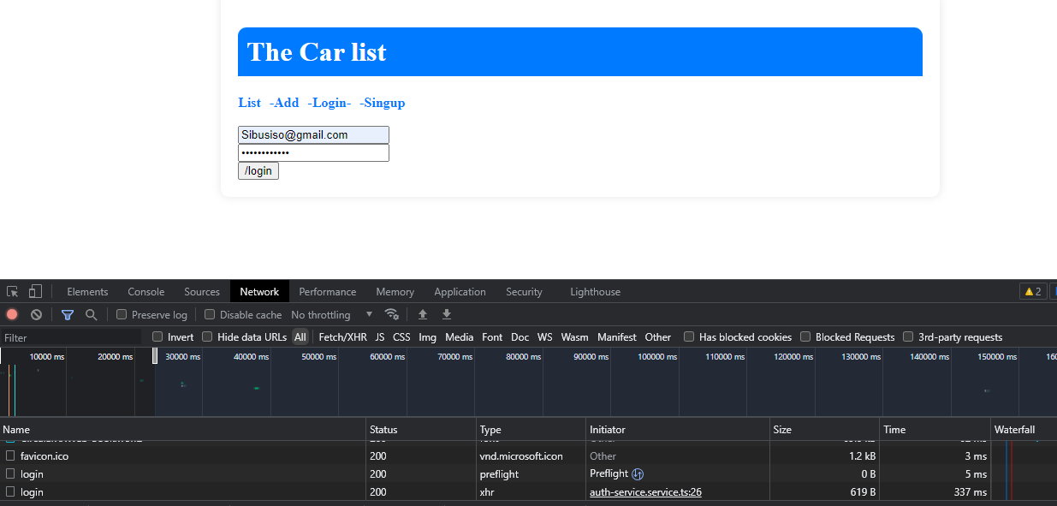

Figure 36: Shows user A logging in again

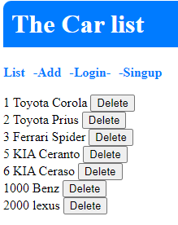Figure 36: shows car list before deletion

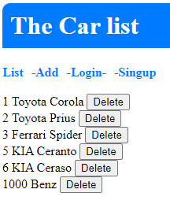Figure 37:shows car Lexus has been deleted from the list

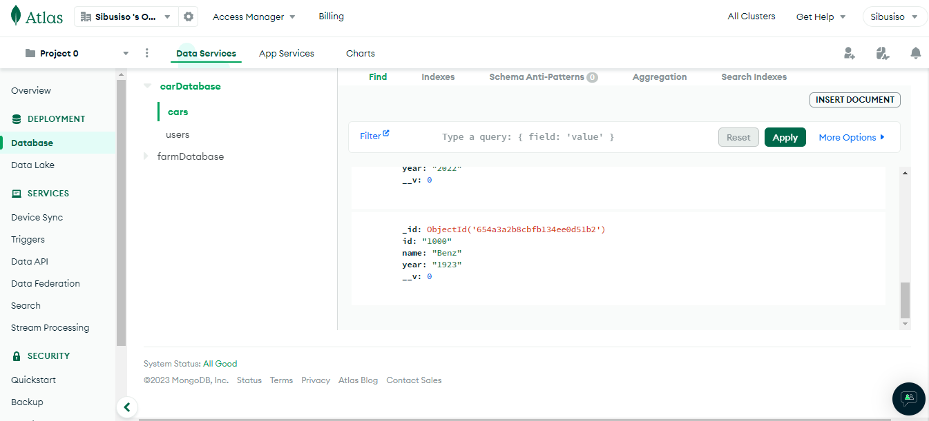

Figure 38: shows car Lexus has been deleted from MongoDB

# Security packages

## Implementing express-brute, helmet, Morgan

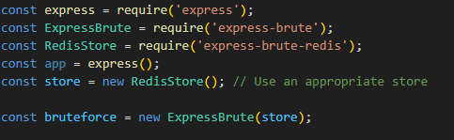

Figure 39 : Shows the implementation of express-brute in the backend workspace

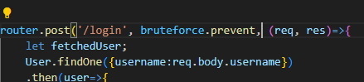

Figure 40: same as figure 39

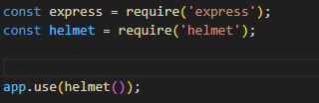

Figure 41: Shows the implementation of helmet in the backend workspace

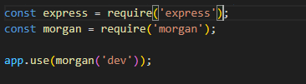

Figure 42: Shows the implementation of Morgan in the backend workspace

# Custom Error Messages

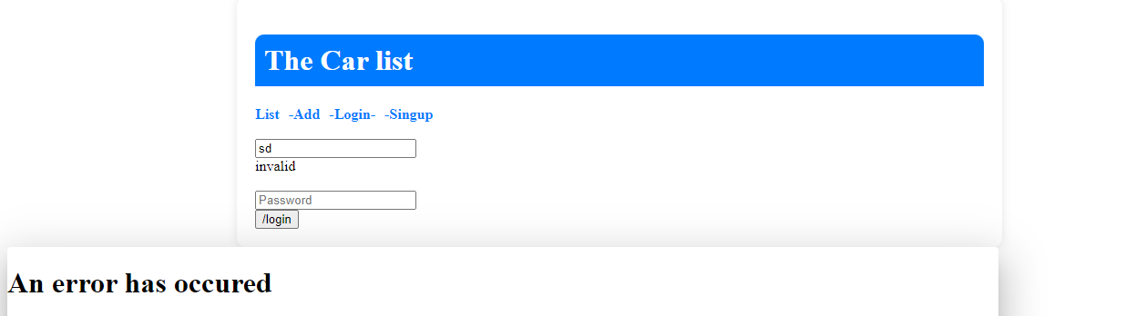

Figure 43 : shows the custom message for when an error is caught

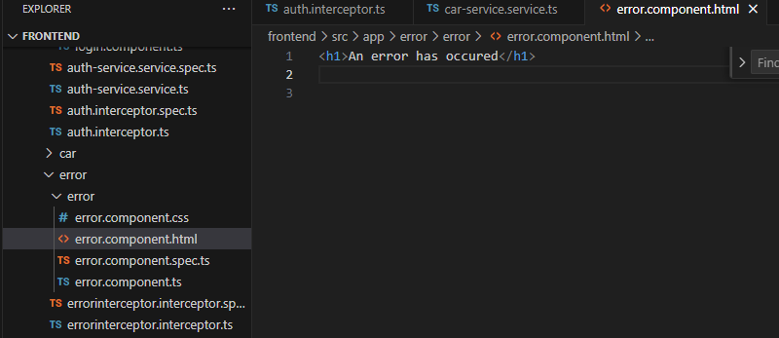

Figure 44: shows the code for custom error messages

# Security input field validation, password obscuring and sanitations

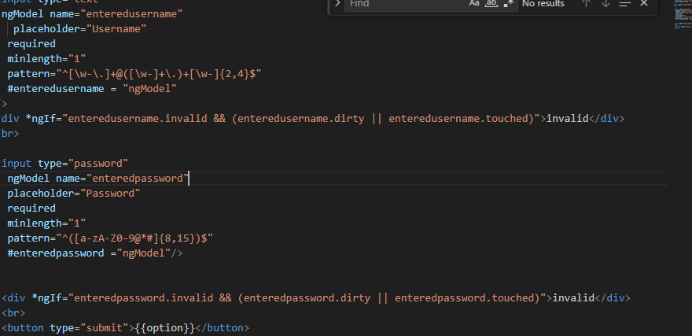

Figure 45: shows the code for input field validation(for username and password), password obscuring(hides password ‘*****’) and sanitations (enteredpassword.dirty).

# Service Auth

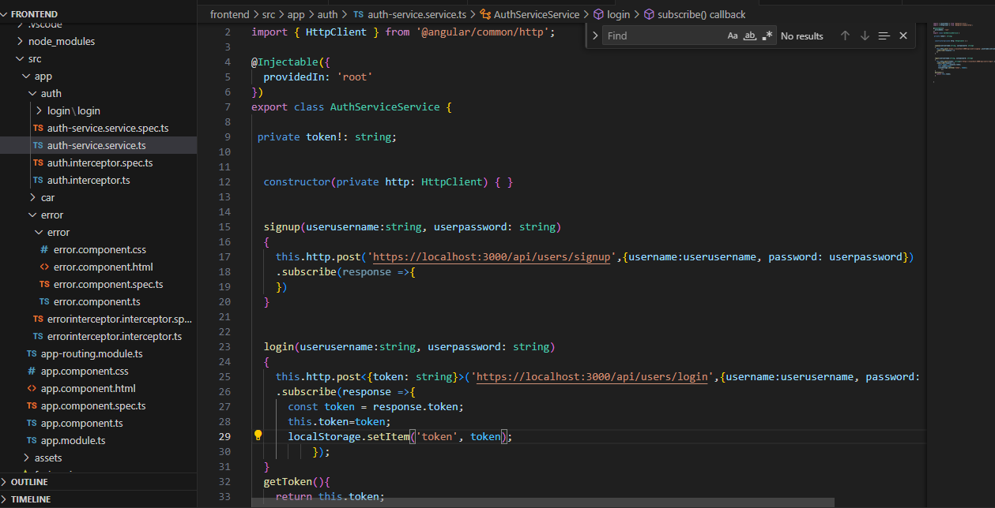

Figure 46 : shows the auth service files code in the front

**No table of contents entries found.**

end